**Minutes: Meeting with Mindstorm (20 September 2022, 2pm -3:00pm)**

- Start Ideation phase, brainstorm either about different types of games in the racing genre or brainstorm on different types of hypercasual games and what new feature can we bring to that game. For example, bring something from AAA title to a hypercasual.

- When the list of videos for game development ideation get compiled, go through each of them to have a basic understanding of game development and what is expected by us.

- After brainstorming, fill in the template provided by Mohsin for accommodation of our ideas and ideology.

- Should play atleast 10 different games of the selected genre/type to get feel of the type of games and what new feature to add on top of it.

- ping faizan when the ideation is ready

**Minutes: Meeting with Mindstorm (26 September 2022)**

Tilting a phone is considered a slight inconvenience for the end user, because the player has to utilize both hands to play the game. A game which can be played using two hands is considered easy to play.

We have to think of 3 ways in which we can integrate social elements/features into the game (Abdullah's personal assignment)

Continuously keep researching how new racing/driving games are evolving, what unique features are they bringing to the market.

What will be the starting animation sequence, for example, showing progression from thieves to our car. Are we the thieves and what are we being chased by? The animation should be short and under 8 seconds so that the player does not get bored. Plus animation generation expertise is required for a good animation, which we don't have.

Endless runners are very old designs. Temple Run etc are popular because they're old, those types of games not suited for today's environment.

Live and breathe the racing genre for next 8-9 months in research. Live in present and check out games of today.

Game controls should be easy to learn and easy to use too.

We will have to learn path generation if using Unity maps. Unity should generate itself again to give infinite track. Landscaping + titling leads to loss of audience as game controls become specific

Our idea is not very marketable but not a problem for Sproj.

Before the next meeting Install 10 games(5 driving, 5 racing) which have 1M+ downloads and play them for at least 1 hour. Understand how the game mechanics, logic work. Finalize the narrative.

**Minutes: Meeting with Sir Waqar (12 October 2022)**

* Discussed finalized game controls and current plans with sir
* Have to finalize timeline
* Sir advised us on how to devise timetable
* Ask their expectations from our game/us
* Ask technical help and procedure for:
* Animator/Artist
* Programmer
* Write up our game idea and document it in github
* Discussed ideas on how to set game difficulty to appropriate level
* Game’s marketability discussed
* Confirm tools from Mindstorm

**Minutes: Meeting with Faizan (12 October 2022)**

* Path generation discussed
* Game Mechanics discussed
* Add colliders on the path
* Another meeting proposed for technical matters, after we have tried out a few things
* 1st let’s do basic driving tilting, then add other things
* Discussed possibility of 3 socialization ideas of Abdullah, we were urged to implement socializing into game somehow. Broaden the game’s horizons and get this aspect into the plan. Instead of including undercooked ideas in last semester. Would make game stand out.
* Encouraged to try ambitious things, even though game idea isn’t ambitious
* Make this FYP the highlight of your CV. Do your best here.
* GD series: how to make it more long lasting? HCG games don’t usually last more than few weeks, work on trend only? Answer: add something unique
* Further sort out various points of idea: rider profile, gestures, etc. Our idea isn’t fully complete yet.
* Groundwork is to be set up in 1st semester
* For mass marketability, turn off tiliting + cartoonish art + vertical mode but don’t think about market though: do what would impress judges
* Amaan’s technical questions about different scenarios of obstacles, path etc

**Minutes: Meeting with Hussain (12 October 2022)**

* Technical advice on how to implement different aspects of game given in detail
* Went through possibilities for power-ups and obstacles
* Side-assignment given to research on multiplayer possibilities and ways while implementing single-player in 1st month. Check out Photon, Natama etc
* Desirability of different controls discussed
* Recommended hierarchy of folders for different features’ codes
* Advised on Github usage and work division
* Advised to play road rash for ideas
* Advised to learn Unity through Unity Learn’s appropriate examples
* 2 weeks from now, this is needed:

We need level generation. We need bike. We need camera that follows bike at all times. Straight bike movement. Left right bike movement. Divide members and work into bike movement and level generation atm.  
Camera should feel realistic, it should also accelerate and decelerate a bit after the bike, so car will come closer or farther to the camera than constant speed camera distance, but for a little while.

**Minutes: Meeting with Sir Waqar (26 October 2022)**

* 2 weeks’ progress on game reviewed by sir
* Work done: infinite path, importing models, straight and sideways translation movement of bike model
* Issues: camera angle, bike tilt, wheels’ rotation yet to be implemented correctly
* Next work target: after meeting with Mindstorm labs

**Minutes: Meeting with Hussain (31 October 2022)**

• Problems (wheel rotation and bike tilt) discussed.  
• Organization of folders discussed.  
         • Each object should have its own folder and its own scripts to keep the folder structure organized.  
**Rotation Problem:**  
         • Rotate should be local, not global. This can help fix the rotation issue.  
         • The entire body should be linked to wheels through joints and then wheels will move the body.  
**Siderails issue:**  
             • Make sure there is not any gap between the colliders. Check it, especially when the path regenerates.  
**Tilt Problem:**  
             • Use clamps in unity to prevent the object from moving beyond a range. For example, set a 45-degree range on both sides of the object, so that object doesn’t fall beyond that range.  
• Hussain went through the scripts and suggested changes to keep the code clean.  
             • Create a separate folder and create a script to keep all the references in that script. And then access them through a game object of that script. This helps keep the code clean.  
             • Instead of deleting the tile, set it as inactive, reposition it and then make it active again. Doing this will make the rendering fast.  
             • Use LINQ in C#. Helps in reducing the code lines.• A new asset (starter kit) shared by Hussain. Use it and give credit to the author. Or understand the code in that asset and implement it in your bike mechanics.  Just use the bike and not the whole level generation.  
• Discussed what can be added to the game:  
              • Four to Five Levels in the game is enough.  
              • We can also implement jumps of bikes, stunts, and replays to make the game unique.

**Goals - next two weeks:**

•    All the members get hands-on GitHub.  
•    Make branches in GitHub and each member uploads their respective part in those branches so the other members can look at and test their code as well.  
•    Start working on SRS and SDS documents as well to list down the features and designs that you want to implement in the game.  
•    Understand the implementation of the starter kit and apply it to your bike mechanics and path generation.  
•    Add some obstacles, such as oil spills and spike strips, etc.

**Minutes: Meeting with Sir Waqar (9 November 2022)**

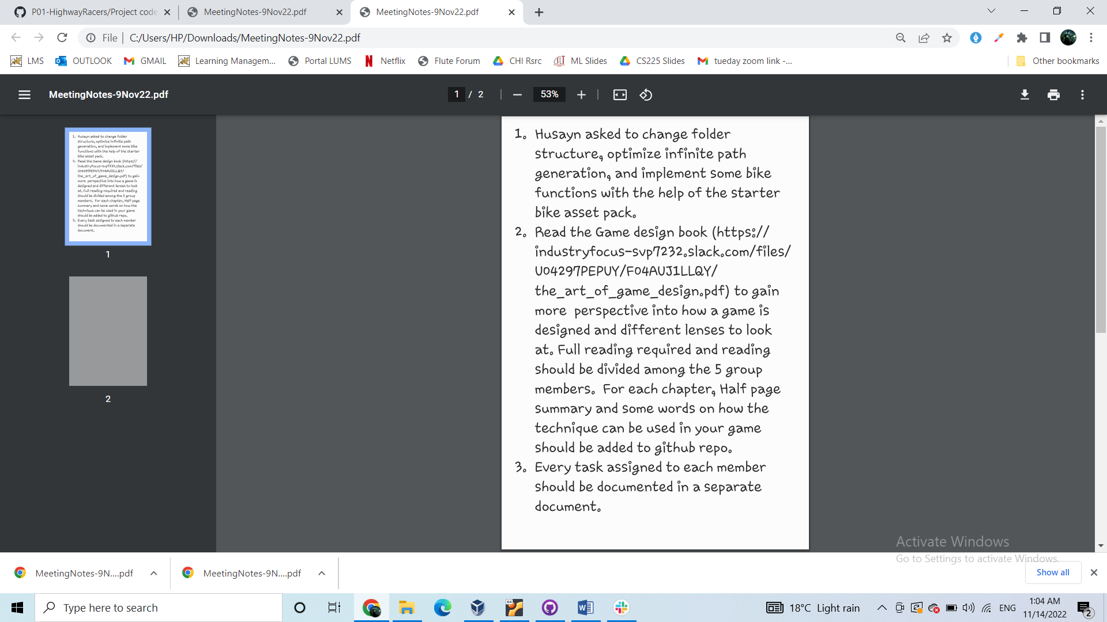

**Minutes: Meeting with Sir Waqar (23 November 2022)**

* Chapters 1-10 of “Art of Game Design” discussed
* New documentation objectives given: Chapters 11-20 and Game Development Methodology
* Updated sir on current game features and shortcomings
* Informed sir of plans for researching future game features over weekend. Currently waiting for meeting with Mindstorm Labs next week.

**Minutes: Meeting with Hussain (29 November 2022)**

* Make the rotation of tyres in the local axis.
* Make SRS and design documents.
* Design Document: Requirements for each feature, implementation of the feature, testing of the feature and any non functional requirements.
* SRS Document: Document containing requirements, objectives of the game.
* Fix the axis of rotation for tyres.If bike is moving forward in z direction, the axis of rotation will be z axis and rotation along other axes would be 0.
* Implement different viewing cameras for different views, such as first-person, follow around cameras in different perspectives. There would be a switch camera button, which upon toggling would switch among different cameras.
* Extend the collider of the walls a little higher.
* There is physics of colliders, which set different properties when one rigid body collides with another rigid body, such as if one ball collides with another ball, causing the balls to bounce.
* Map keyboard input to mobile input.
* Start working on UI, like start game button, accelerate button.
* Put the camera on top, and put canvas on bottom.
* Reference resolution is 1080p(width,X) x 1920(height,Y)
* Use Panel as container for UI.Everything else like buttons, should be placed within a panel. There can be panels within panels. Like the title at the top. The bike description in the center.
* Button title should be above the button so that its title appears on top of the button.
* Create Game start UI, and present working over the weekend.
* Create Pause Menu, button to resume.
* Create a Game End menu.
* Create Left , Right buttons for left and right movement.
* Create moveLeft function, moveRight function and map the functions to the Left and Right buttons.